AI StudyBuddy - - AI assistant for smarter learning and study support.

Description
AI StudyBuddy is an AI-powered learning assistance platform developed to simplify the study process for students by leveraging modern web technologies and Generative AI. The application provides an intelligent backend system that enables students to upload study materials, generate concise summaries, create flashcards, produce quizzes, and receive personalized study plans through AI-generated responses. The backend is developed using Node.js and Express.js, following a RESTful API architecture that ensures scalability, maintainability, and secure communication between the frontend and backend services. MongoDB serves as the primary NoSQL database, while Mongoose ODM provides schema validation, data modeling, and efficient database interactions. To secure user information and protected resources, the application implements JWT (JSON Web Token) based authentication along with Role-Based Access Control (RBAC). Users are authenticated before accessing AI-powered features, ensuring that only authorized users can utilize premium learning services. Passwords are securely encrypted using bcryptjs, preventing unauthorized access to user credentials.
One of the key highlights of AI StudyBuddy is its integration with the Google Gemini AI API, which enables the application to perform advanced natural language processing tasks. Instead of relying on predefined templates, the backend dynamically communicates with the Gemini model to generate high-quality educational content based on the study material provided by the user.

Scenario-Based Case Study

Background
Students often prepare for semester examinations while simultaneously learning new technical skills for higher studies, internships, and placement opportunities. Their study materials are usually scattered across lecture notes, PDFs, textbooks, online articles, and other resources, making it difficult to organize, revise, and manage learning effectively.
Due to the large volume of study content and limited preparation time, students may struggle to identify important concepts, prepare concise revision notes, create practice questions, and track their learning progress. Traditional study methods require considerable manual effort to summarize lengthy materials, prepare revision resources, and create study schedules. This process can be repetitive and time-consuming, making effective and consistent learning difficult.
Therefore, our project aims to develop an AI-powered Study Buddy that helps students organize their study materials and automatically generate summaries, flashcards, quizzes, and personalized study plans, enabling more efficient revision and better learning management.
Team Details
Project Title -AI-STUDDY BUDDY
- U.Monisha
- P.Subasree
- S.Sandhiya
- A.Swetha
- B.Mohanalakshmi

Problem
Rahul encounters several challenges during his preparation:
- Difficulty understanding lengthy study materials within limited time.
- Manual preparation of notes consumes a significant amount of study time.
- Creating flashcards and revision questions is repetitive and labor-intensive.
- Lack of personalized study plans based on available time and examination schedules.
- No centralized platform to securely store AI-generated learning resources.
- Difficulty assessing knowledge through self-generated quizzes.
- Switching between multiple applications for note-taking, quizzes, and scheduling reduces productivity.

Solution
The AI StudyBuddy backend provides a centralized, AI-powered learning platform that automates several academic tasks through intelligent content generation. The system enables authenticated users to upload or enter study materials and leverage the Google Gemini AI API to generate educational resources automatically.
The backend processes incoming requests through secure RESTful APIs and performs the following operations:
- Authenticates users using JWT-based security.
- Stores user information and study resources in MongoDB.
- Sends study content to the Google Gemini AI model through dedicated AI service modules.
- Generates concise summaries for faster revision.
- Creates flashcards for active recall learning.
- Produces multiple-choice quizzes for self-assessment.
- Generates personalized study plans based on user preferences and examination timelines.
- Stores generated learning resources for future retrieval and continuous learning.
By separating authentication, business logic, database operations, and AI processing into modular components, the backend ensures maintainability, scalability, and efficient request handling.

Usage

Student Usage
Students register and log in to the application before accessing AI-powered learning features. After authentication, they can upload study material or provide textual content and choose the desired AI functionality, such as generating summaries, quizzes, flashcards, or personalized study plans. The generated content can be reviewed immediately and stored for future reference.

Administrator Usage
Administrators manage registered users, monitor application activity, oversee system usage, and maintain platform integrity. Administrative privileges include managing user accounts, monitoring AI service utilization, reviewing system logs, and ensuring smooth backend operations.

Outcome
By integrating artificial intelligence with a secure backend architecture, AI StudyBuddy significantly improves the learning experience for students. Manual preparation time is reduced through automated content generation, allowing students to focus more on understanding concepts rather than organizing study materials.
The implementation of JWT authentication, MongoDB data management, and Google Gemini AI integration ensures that educational resources are generated securely, efficiently, and consistently. The modular backend architecture further supports future enhancements, enabling additional AI-powered learning capabilities to be integrated with minimal architectural changes.
As a result, AI StudyBuddy serves as a scalable and intelligent educational platform that enhances productivity, promotes effective revision, and supports personalized learning for students preparing for academic examinations and competitive assessments.

Software Requirements
- Operating System: Windows 10/11, macOS, or Linux (supports cross-platform operations).
- Node.js (v16 or above): Runtime ecosystem running server logic and routing infrastructure.
- npm (v8 or above): Node package manager to control operational dependencies.
- Express.js: Lightweight routing web framework to construct backend RESTful entry points.
- MongoDB: Document NoSQL engine storing users, posts, categories, comments, and analytics metrics.
- Postman: API verification toolkit to assert schema validation responses across administrative route shields.
- Code Editor: Visual Studio Code or similar IDE environment.

Hardware Requirements
- Processor: Intel Core i5 (8th Gen or above) / AMD Ryzen 5 or equivalent.
- RAM: 8 GB minimum (16 GB recommended for concurrent instances of MongoDB, processing layers, and execution nodes).
- Storage: 1 GB of available disk workspace.

Epic 1: Project Architecture

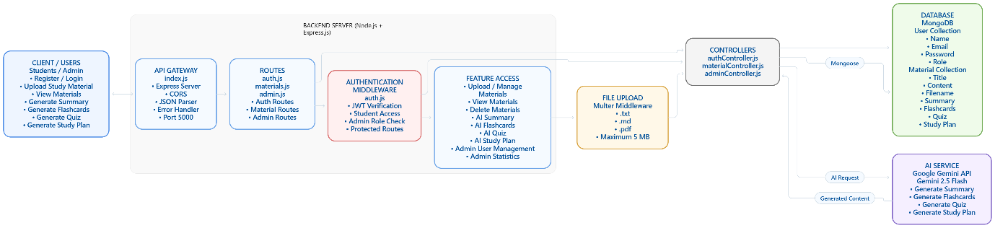

The AI StudyBuddy backend follows a modular RESTful architecture designed to provide secure, scalable, and AI-powered learning services. The system processes client requests through Express.js, validates users using JWT authentication, interacts with the MongoDB database for data storage, and communicates with the Google Gemini AI API to generate intelligent study resources.
The architecture separates authentication, business logic, AI services, and database operations into independent modules, making the application easier to maintain, extend, and debug.

Components Definition
• Client Application: The frontend (React.js) allows users to register, log in, upload study material, and access AI-powered features such as summaries, quizzes, flashcards, and study plans through REST APIs.
• Express Server: The Express.js server receives HTTP requests, handles routing, processes middleware, and sends appropriate responses to the client.
• Authentication Middleware: JWT-based middleware verifies user identity, protects private routes, and ensures that only authenticated users can access AI services and study resources.
• Route Handlers: Routes manage API endpoints related to user authentication, study materials, AI features, and administrative operations.
• AI Service Layer: A dedicated AI service communicates with the Google Gemini API to generate summaries, quizzes, flashcards, and personalized study plans based on the user's study content.
• Database Layer: MongoDB, together with Mongoose ODM, stores user information, uploaded study materials, and AI-generated learning resources securely.

Entity-Relationship (ER) Diagram Description

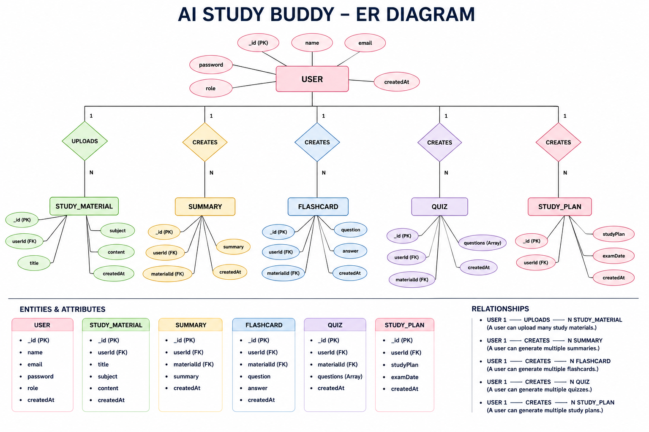
The AI StudyBuddy backend manages data through interconnected MongoDB collections that store user information, study materials, and AI-generated learning resources. Each entity is linked using logical relationships to ensure efficient data management and retrieval.

1. User Entity
Stores the details of registered users and administrators.

Attributes:

_id (Primary Key – ObjectId)

name (String, Required)

email (String, Required, Unique)

password (String, Hashed)

role (String – student / admin)

createdAt

updatedAt

The password is securely hashed using bcryptjs before storing it in MongoDB.

2. Study Material Entity

Stores study materials uploaded by authenticated users and the AI-generated learning resources associated with each material.

Attributes:

_id (Primary Key – ObjectId)

user (Foreign Key → User)

title (String, Required)

content (String, Required)

filename (String)

summary (String)

flashcards (Array)

question

answer

quiz (Array)

question

options

answer

studyPlan (String)

createdAt

updatedAt

3. Summary

In the current implementation, Summary is not maintained as a separate MongoDB entity.

The AI-generated summary is stored directly inside the corresponding Study Material document using the summary field.

Stored as:

Material

└── summary

The summary is generated using the Google Gemini API based on the uploaded study material.

4. Flashcards

Flashcards are not stored as a separate MongoDB collection.

They are stored as an array inside the Study Material entity.

Attributes:

flashcards

├── question

└── answer

One study material can contain multiple flashcards.

Relationship:

Study Material → Flashcards (One-to-Many)

5. Quiz

Quiz is not maintained as a separate MongoDB entity.

It is stored as an array inside the Study Material entity.

Attributes:

quiz

├── question

├── options

└── answer

One study material can contain multiple multiple-choice questions.

Relationship:

Study Material → Quiz Questions (One-to-Many)

6. Study Plan

Study Plan is not maintained as a separate MongoDB entity.

The generated study plan is stored directly inside the corresponding Study Material document.

Attribute:

studyPlan

The study plan is generated based on:

Student's goal

Available study hours per day

Number of study days

Uploaded study material

Key Relationships

1. User → Study Material (One-to-Many)

A user can upload multiple study material

The Material.user field references the User document.

2. Study Material → Summary (Embedded)

Each study material can contain an AI-generated summary.

MATERIAL

│

└── summary

3. Study Material → Flashcards (One-to-Many)

One study material can generate multiple flashcards.

MATERIAL

│

└── flashcards[]

├── question

└── answer

4. Study Material → Quiz (One-to-Many)

One study material can generate multiple quiz questions.

MATERIAL

│

└── quiz[]

├── question

├── options[]

└── answer

5. Study Material → Study Plan (Embedded)

Each study material can contain an AI-generated study plan.

MATERIAL

│

└── studyPlan

6. User → AI Resources

All generated AI resources are associated with the user's uploaded material through the Material.user reference.

Key Features

The AI StudyBuddy backend provides intelligent learning assistance through secure REST APIs. The major features are:

Secure User Authentication

Implements JWT-based authentication with bcryptjs password hashing.

The system provides:

User registration

User login

Access token generation

Refresh token generation

Token refresh

Logout response

Study Material Management

Authenticated users can:

Upload study materials

View study materials

View individual materials

Delete materials

The system supports:

.txt

.md

.pdf

files with a maximum upload size of 5 MB.

AI Summary Generation

The system sends uploaded study material to the Google Gemini API and generates a clear and concise summary.

The generated summary is stored in:

Material.summary

AI Flashcard Generation

The system automatically generates flashcards from uploaded study material.

Each flashcard contains:

question

answer

Multiple flashcards are stored inside:

Material.flashcards[]

AI Quiz Generation

The system generates multiple-choice questions using the uploaded study material.

Each quiz question contains:

question

options[]

answer

The generated questions are stored in:

Material.quiz[]

AI Study Plan Generation

The system generates a personalized study plan using:

Student goal

Hours available per day

Number of study days

Study material

The generated plan is stored in:

Material.studyPlan

Role-Based Access Control

The system supports two roles:

student

admin

Students can access their own study materials.

Administrators have additional permissions for system management.

Admin Management

Administrators can:

View all users

Delete users

Delete the user's associated materials

View total student count

View total material count

MongoDB Data Storage

MongoDB is used to store:

User information

Study materials

AI-generated summaries

Flashcards

Quiz questions

Study plans

Roles and Responsibilities

Student

Students are the primary users of the system.

They can:

Register

Login

Upload study materials

View their materials

Delete their materials

Generate summaries

Generate flashcards

Generate quizzes

Generate study plans

Access their generated learning resources

Students can only access their own materials.

Administrator

Administrators have system-level management permissions.

They can:

View all registered users

Delete users

Automatically delete materials belonging to deleted users

View system statistics

Monitor the number of students

Monitor the number of uploaded study materials

Admin-only routes are protected using the adminOnly middleware.

User Flow

The AI StudyBuddy application begins when a student or administrator registers or logs into the system.

Register / Login

↓

JWT Authentication

↓

Dashboard

↓

Upload Study Material

↓

Material Stored in MongoDB

↓

Select AI Feature

↓

────────────┬─────────────────┐

│ │ │ │

▼ ▼ ▼ ▼

Summary Flashcards Quiz Study Plan

│ │ │ │

└───────────────┴────────────────┴

↓

Google Gemini API

↓

Generated Content

↓

MongoDB

↓

Display to User

MVC Architecture Pattern

The AI StudyBuddy backend follows a modular MVC-style architecture.

CLIENT

│

▼

ROUTES

│

▼

MIDDLEWARE

│

▼

CONTROLLERS

│

├────────
Project Setup and Configuration

Creating the Project Folder

- Create a new folder named AI StudyBuddy .
- Open the project folder in Visual Studio Code.
- Initialize the project using Node.js and install the required dependencies.

Project Initialization

Open the project folder in the VS Code terminal and execute:

npm init -y

Install the required dependencies:

npm install express mongoose bcryptjs jsonwebtoken cors dotenv multer @google/genai

Install Nodemon for development:

npm install --save-dev nodemon

Create the Following Files

- index.js
- .env
- package.json
- .gitignore

Create the Following Folder Structure
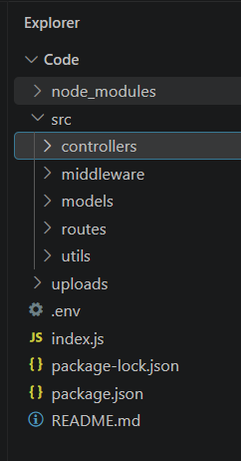

Backend Structure
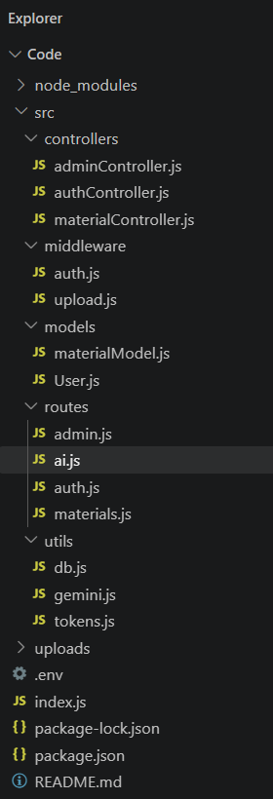

Core System Script Implementations

1. Application Entry Point (index.js)
The index.js file serves as the main entry point of the application. It initializes the Express server, loads environment variables, configures middleware, establishes the MongoDB connection, registers API routes, and starts the server after a successful database connection.
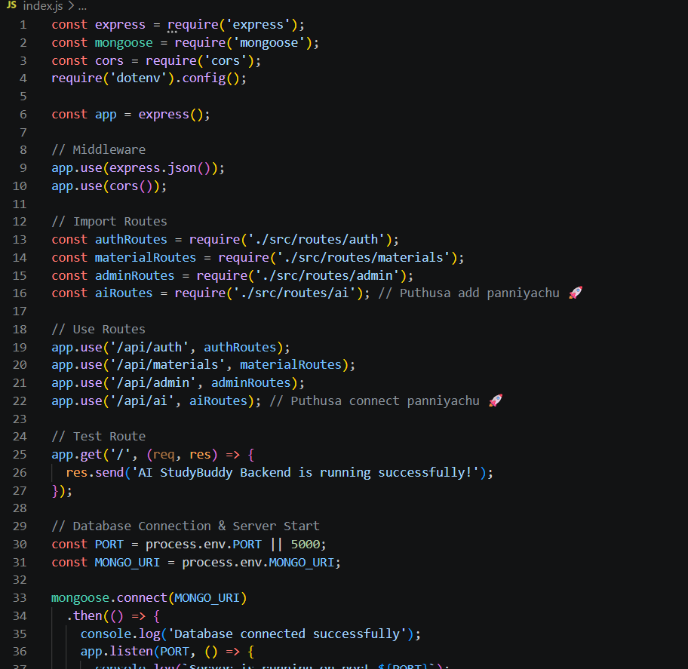

2. Database Connection (src/utils/db.js)
This module establishes a connection between the application and MongoDB using Mongoose. It ensures that the backend communicates with the database before processing any client requests.
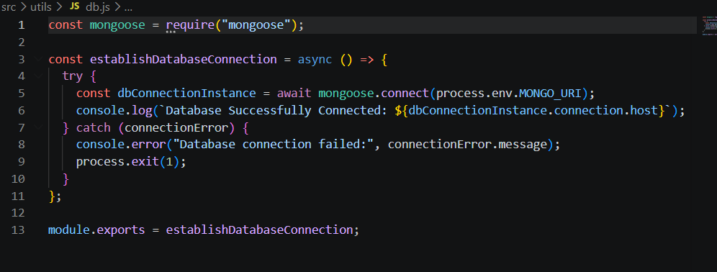

3. Authentication Middleware (src/middleware/auth.js)
The authentication middleware verifies JWT access tokens for protected routes. It authenticates users before granting access to secured APIs and includes role-based authorization to restrict administrative operations.
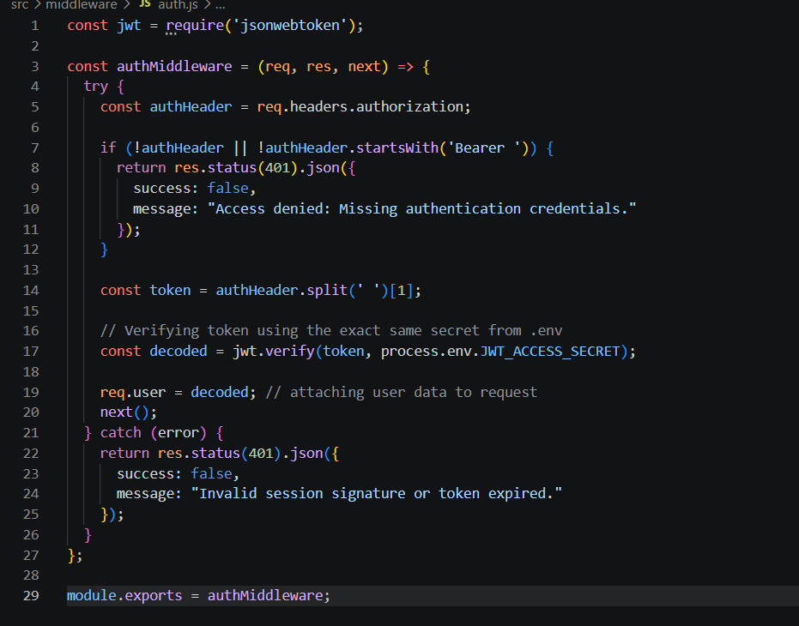

4. AI Integration (src/utils/gemini.js)
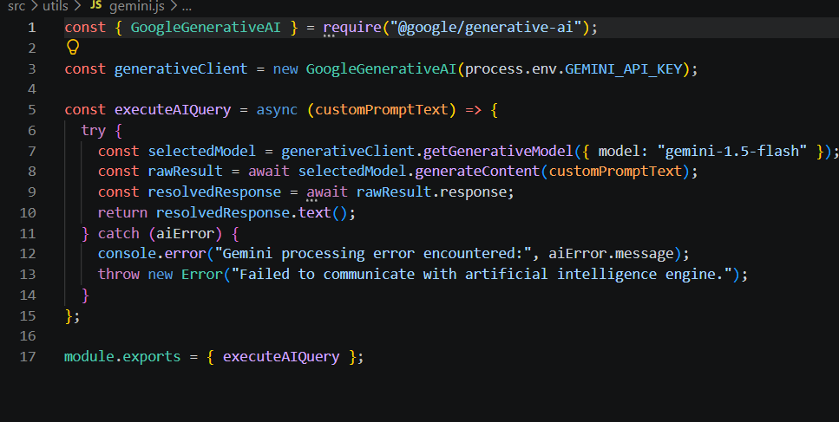
This utility integrates the backend with the Google Gemini 2.5 Flash API. It sends prompts to the AI model and returns generated responses for summaries, flashcards, quizzes, and study plans.

5. File Upload Middleware (src/middleware/upload.js)
The upload middleware handles study material uploads and validates incoming files before they are processed by the backend.

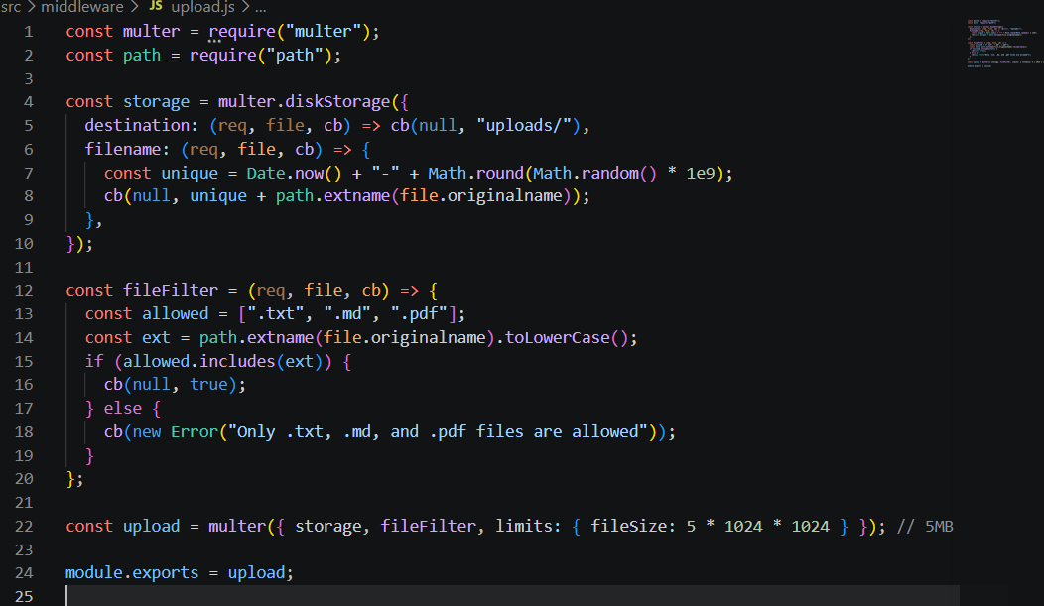Epic 4: Database Configuration
The AI StudyBuddy backend uses MongoDB as its primary NoSQL database and Mongoose ODM for data modeling and schema validation. MongoDB stores user information, uploaded study materials, and AI-generated learning resources in a structured manner. Mongoose simplifies database operations by providing schemas, validation rules, and efficient query handling.

Configure MongoDB
Install Mongoose using the following command:
npm install mongoose

Create Database Connection
Before performing any database operations, establish a connection between the backend and MongoDB using Mongoose. The connection module is initialized during server startup to ensure reliable communication with the database.

Mongoose Schema Definitions

1. User Schema (models/User.js)
The User schema stores authentication and profile information for registered users. It includes fields such as name, email, password, and role. Passwords are securely encrypted before being stored in the database.
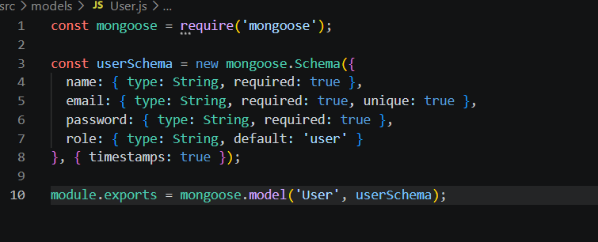

2. Study Material Schema (models/materialmodel.js)
The Study Material schema stores the learning content uploaded by users. This content acts as the input for AI-powered features such as summaries, quizzes, flashcards, and study plans.
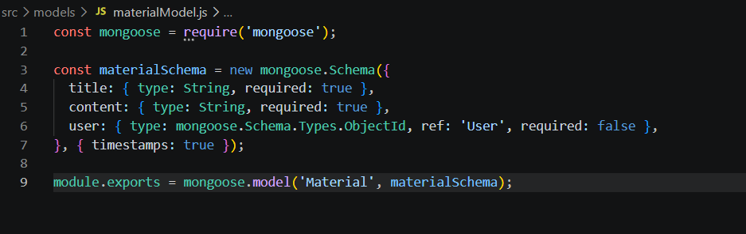

Database Collections
The AI StudyBuddy database consists of the following collections:
- Users – Stores user account and authentication details.
- Study Materials – Stores uploaded learning materials.

API Route Interface Endpoints
The backend exposes RESTful APIs to interact with the database and AI services.

1. Authentication APIs
Handles user registration, login, JWT authentication, and protected route access.

2. Study Material APIs
Allows users to upload, retrieve, update, and manage study materials.

3. AI Feature APIs
Provides endpoints for:
- AI Summary Generation
- AI Flashcard Generation
- AI Quiz Generation
- AI Study Plan Generation

4. Administrative APIs
Provides administrator-only endpoints for managing users and monitoring system activities.

Epic 5: Project Execution
The AI StudyBuddy backend can be executed locally using Node.js. Before running the application, ensure that MongoDB is running and the required environment variables are configured correctly. The backend exposes REST APIs that can be tested using Postman or Thunder Client.

Running the Backend Server
Install all required dependencies:
npm install
Start the development server:
npm start
After successful execution, the server connects to MongoDB and starts listening for incoming API requests.

API Testing
The backend APIs can be tested using Postman.

1. User Registration
Registers a new user by accepting the required details and securely storing the encrypted password in the MongoDB database.
Endpoint:
POST /api/auth/register
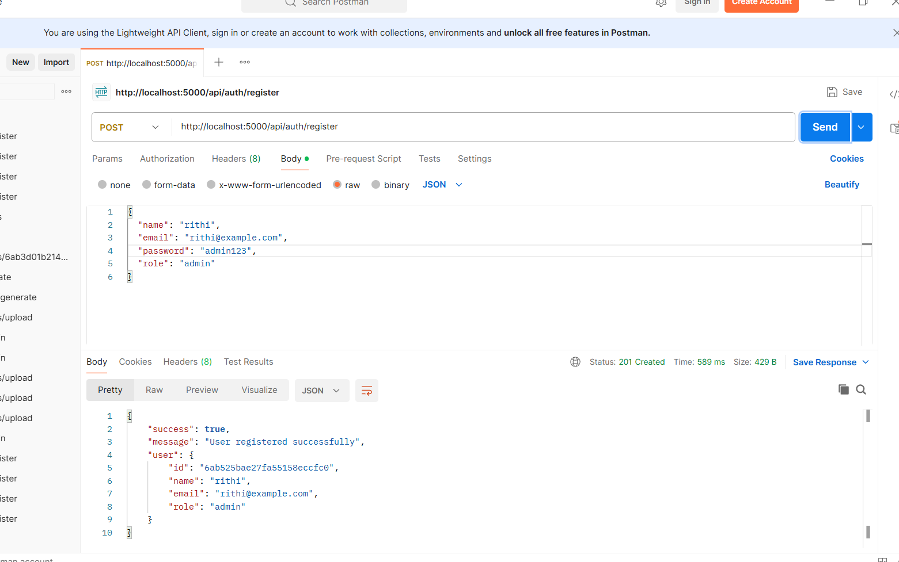

2. User Login
Authenticates the registered user and generates a JWT access token for accessing protected APIs.
Endpoint:
POST /api/auth/login
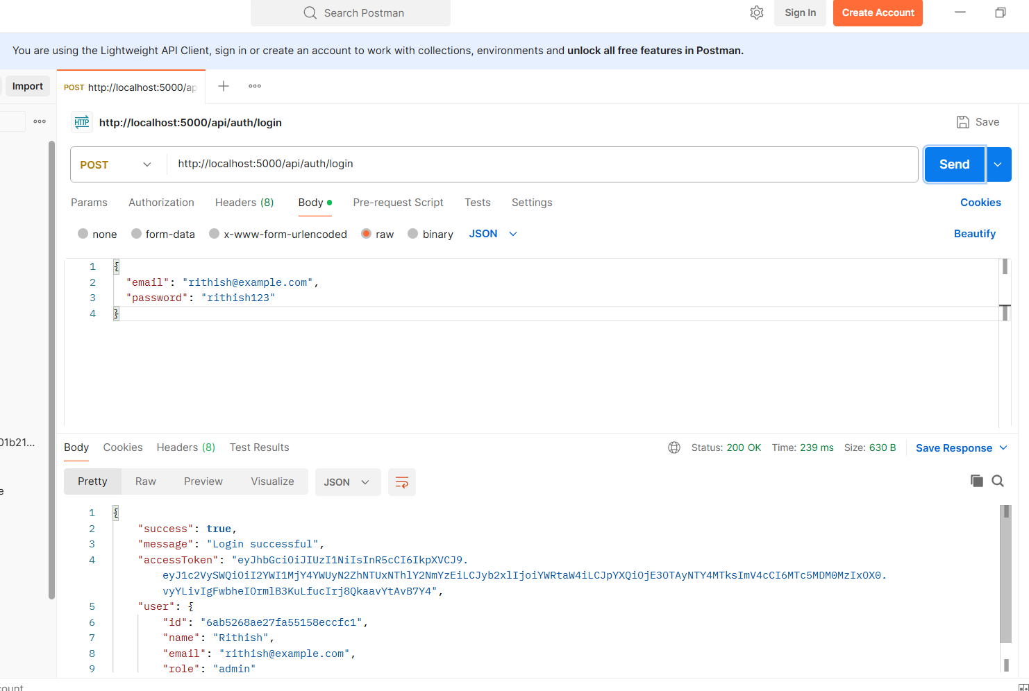

3. Upload Study Material
Allows authenticated users to upload study material that will be used as input for AI-powered content generation.
Endpoint:
POST /api/material/upload
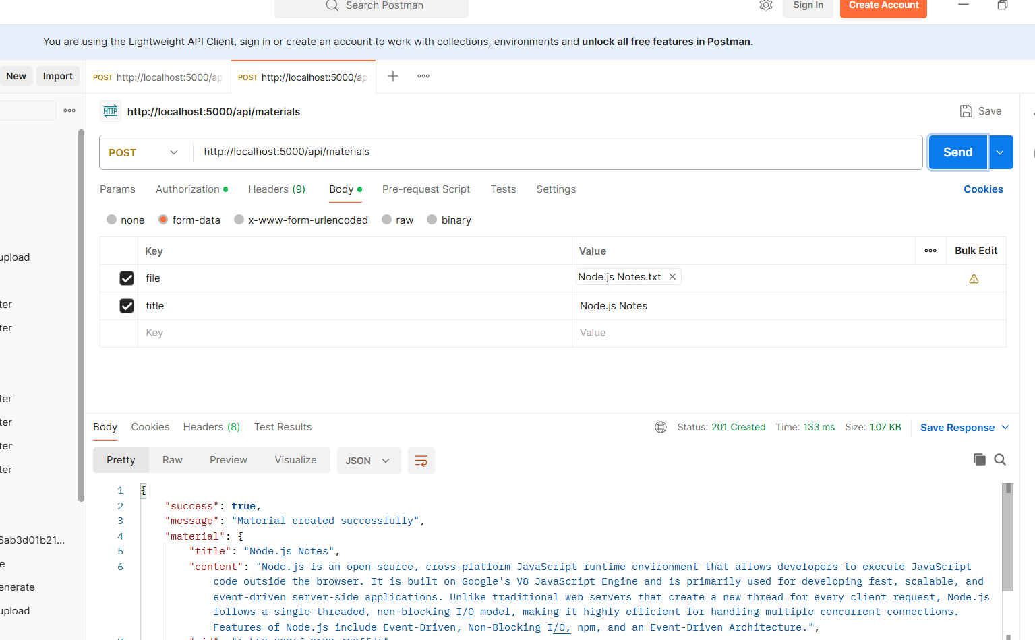

4. Generate AI Summary
Sends the uploaded study material to the Google Gemini API and generates a concise summary.
Endpoint:
POST /api/materials/:id/summarize
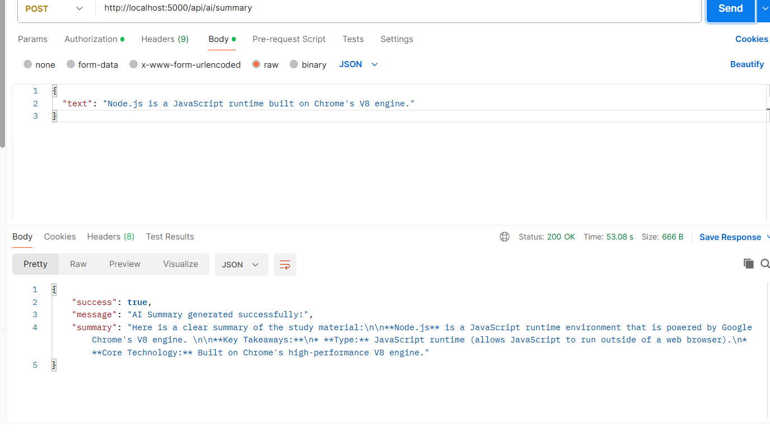

5. Generate AI Flashcards
Creates AI-generated flashcards from the uploaded study material for effective revision.
Endpoint:
POST /api/ai/flashcards
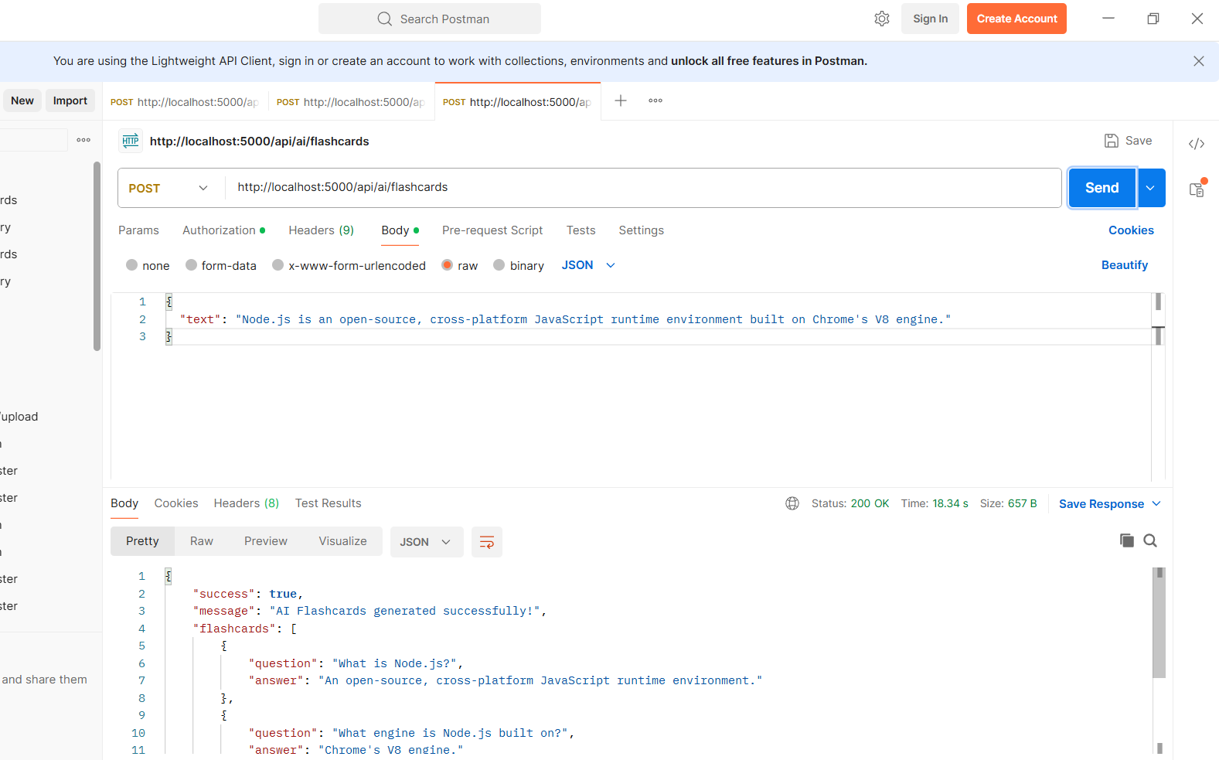

6. Generate AI Quiz
Generates multiple-choice questions from the uploaded study material to help users assess their understanding.
POST /api/ai/quiz

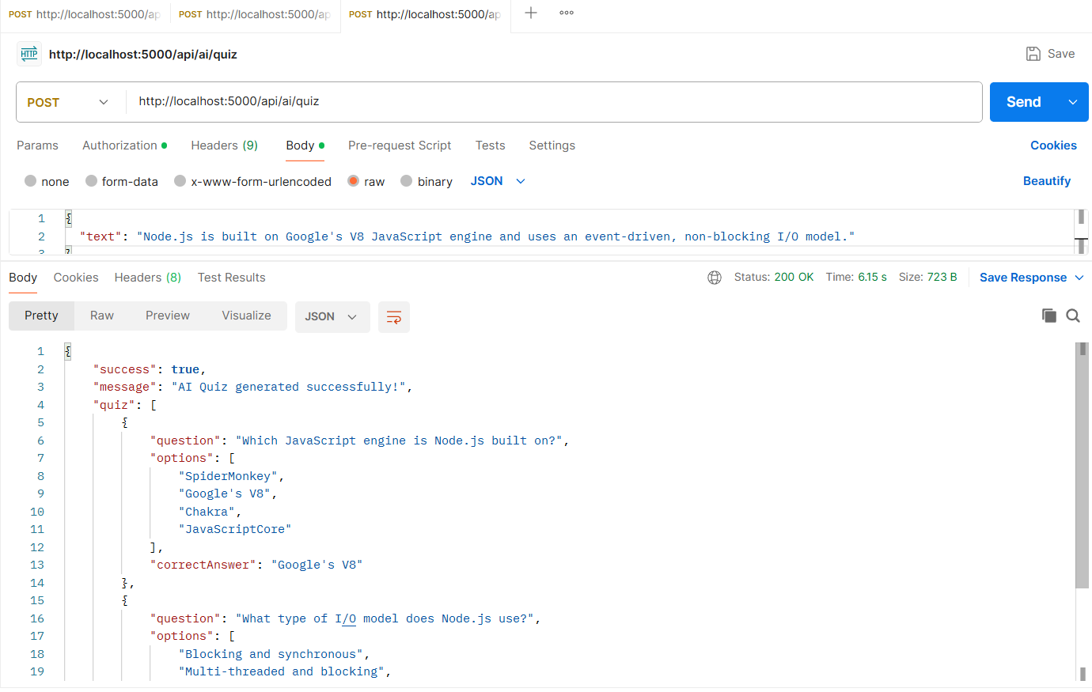

7. Generate AI Study Plan
Creates a personalized study schedule based on the user's learning goals and available study time.
Endpoint:
POST /api/ai/study-plan
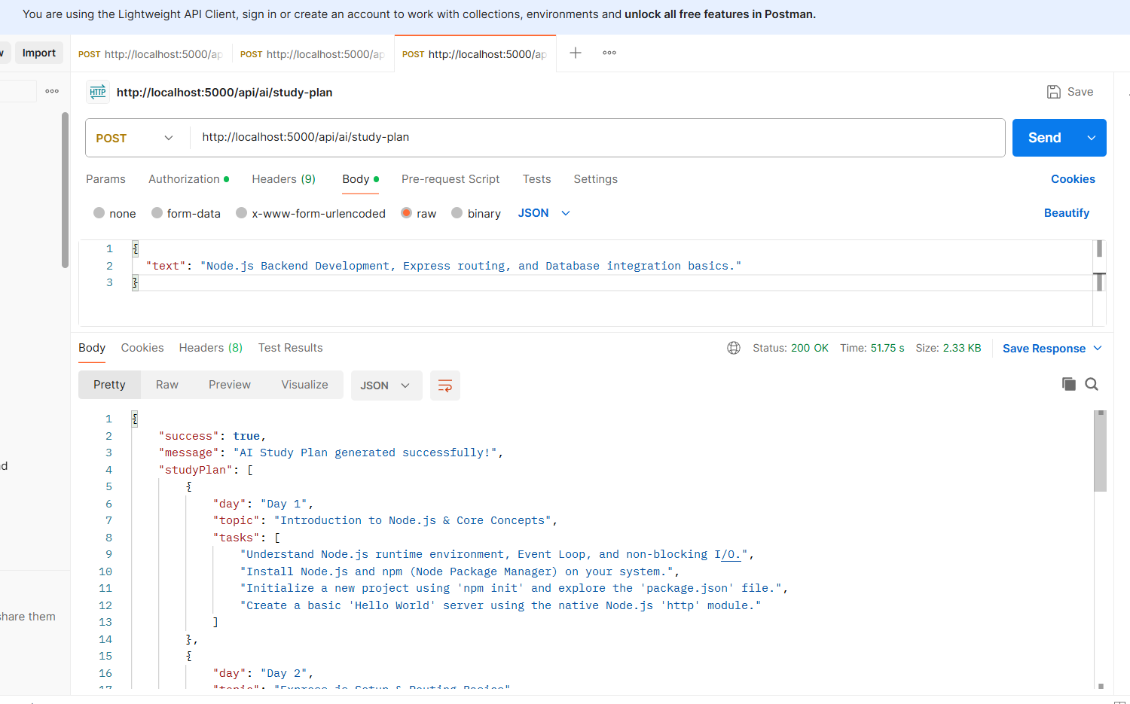

API TESTING LINK: https://drive.google.com/file/d/1MF7WXBIMmck2sfnCUjLiPAZvdAlNa6Yl/view?usp=drive_link
CODE DEMO LINK: https://drive.google.com/file/d/1FTfdal0uMIHRaXrlL7T4RMRhSljGWu0t/view?usp=drive_link
CODE DRIVE LINK: https://drive.google.com/drive/folders/10zejiQCYraXzbar0QYINuKNWUK8VmNg2?usp=sharing

